2. Display future leap years from current year to a final year entered by user.

s=int(input("enter start year"))

e=int(input("enter end year"))

if(s<e):

print("leap years are:",end=" ")

for i in range(s,e):

if i%4==0 and i%100!=0:

print(i,end=" ")

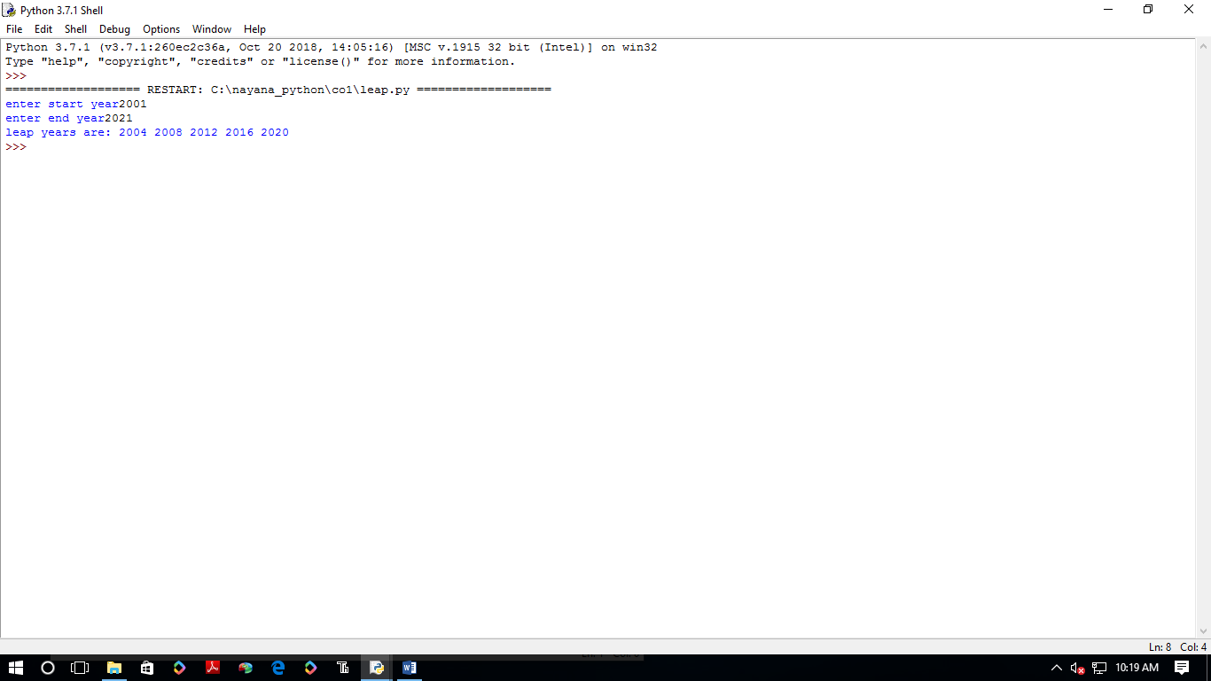

3.**List comprehensions:**

list=[2,-6,4,-8,5,-7,1,2]

n=[num for num in list if num>0]

print(n)

n=int(input(" enter the limit"))

zlist=[i**2 for i in range(1,n+1)]

print("square of no=",zlist)

n=str(input("enter the string"))

for i in n:

if(i in 'a,e,i,o,u'):

print("vowels=",i)

y=input("enter word")

for i in y:

print(i)

print(ord(i))

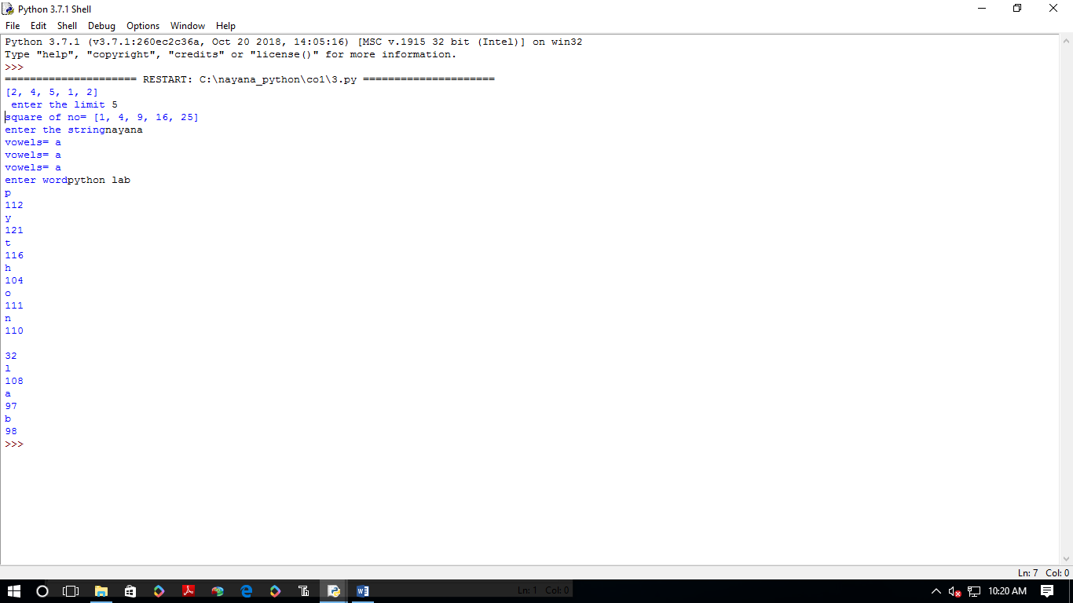

1. **Count the occurrences of each word in a line of text.**

**str1=str(input("enter the string"))**

**word= str1.split()**

**count=[]**

**for w in word:**

**count.append(word.count(w))**

**print("count occurence is",str(list(zip(word,count))))**

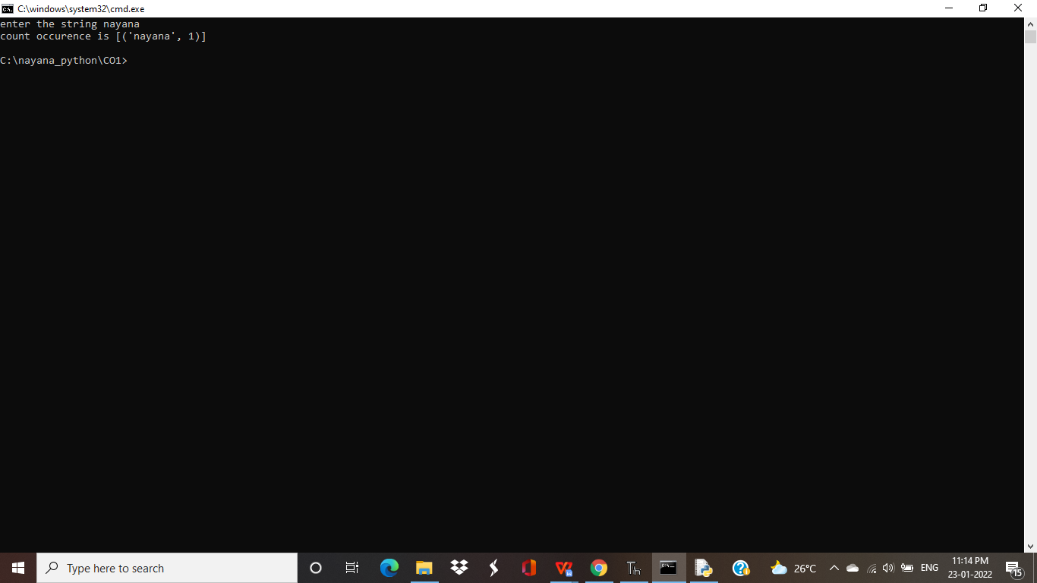

**5.**Prompt the user for a list of integers. For all values greater than 100, store ‘over’ instead

n=[]

s=int(input("Enter a limit:"))

print("Enter {s} values")

for i in range(0,s): n.append(int(input()))

print("\nThe list after assinging:\n")

for i in range(0,len(n)):

if n[i]>=100:print("over")

else:print(n[i])

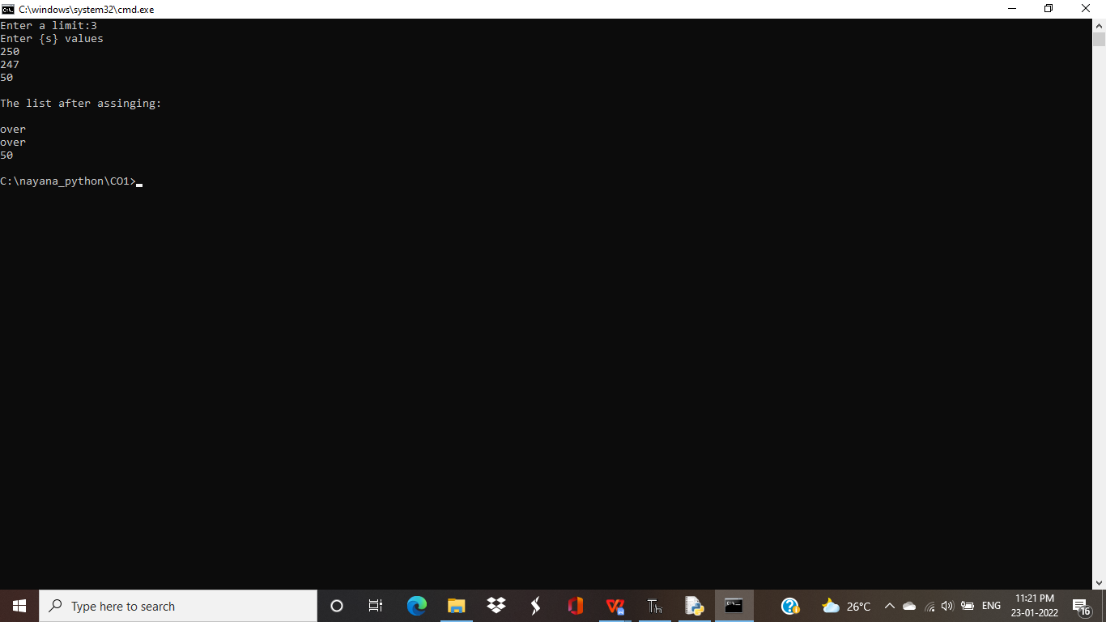

**6. Store a list of first names. Count the occurrences of ‘a’ within the list**

a_list = ["a", "b", "a","c","d","a"]

occ = a_list.count("a")

print("count of occurrences of a :",occ)

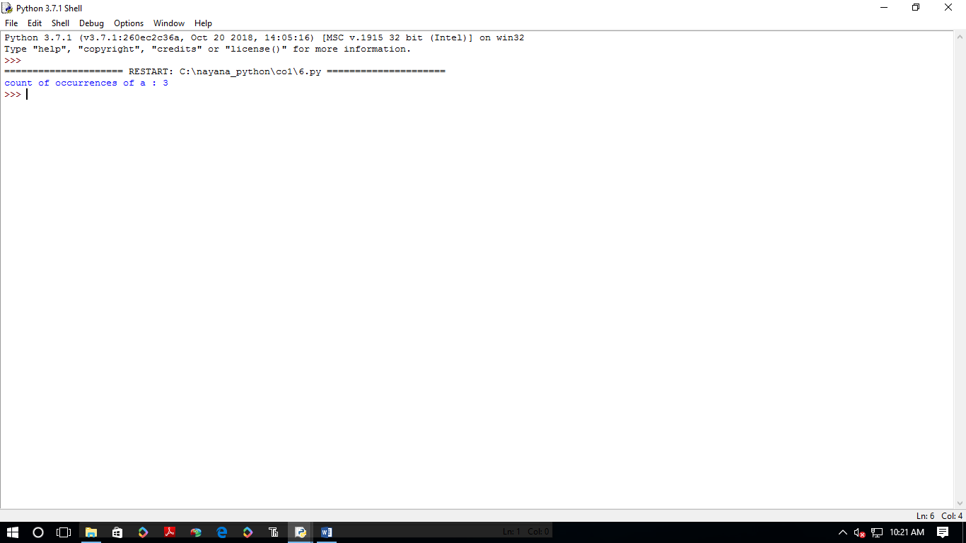

1. Enter 2 lists of integers. Check (a) Whether list are of same length (b) whether list sums to same value (c) whether any value occur in both

lst=[1,3,5,7,9,11,34]

lst1=[5,13,45,7,20,65,1]

s=int(0)

c=int(0)

if len(lst)==len(lst1):

print("Lists are of same length")

else:

print("Lists have different length")

for i in range(0,len(lst) and len(lst1)):

s=s+lst[i]

c=c+lst1[i]

if(s==c):

print("equal sum")

else:

print("not same sum")

print("Elements that matched are:")

l=[]

for i in range(0,len(lst)):

for j in range(0,len(lst1)):

if lst[i]==lst1[j]:

l.append(lst[i] and lst1[j])

else:

continue

print(l)

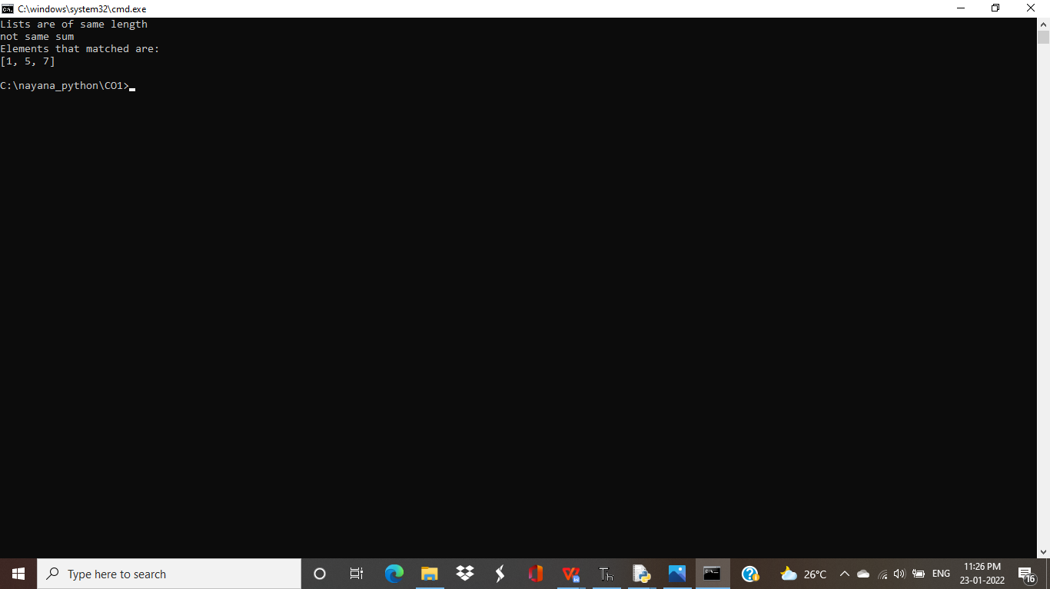

8.Get a string from an input string where all occurrences of first character replaced with ‘$’, except first character. [eg: onion -> oni$n]

str1="nayana"

char = str1[2]

str1 = str1.replace(char, '$')

str1 = char + str1[1:]

print(str1)

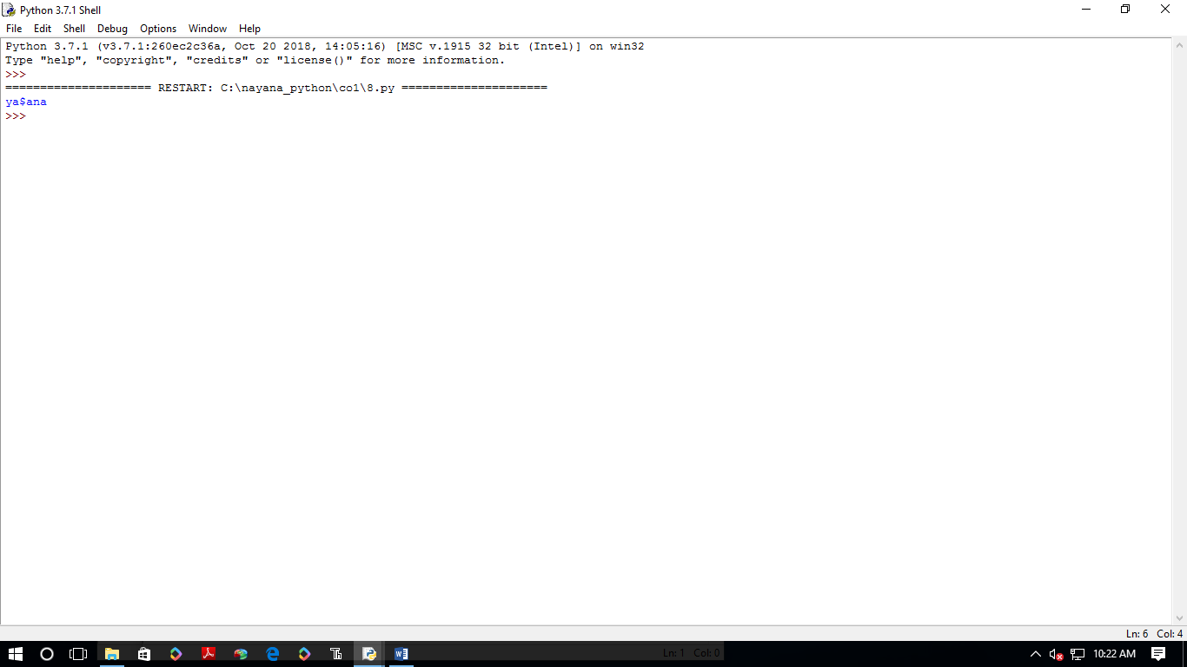

**9.Create a string from given string where first and last characters exchanged. [eg: python -> nythop]**

str = input("Enter a string")

new_str = str[-1:] +str[1:-1] + str[:1]

print("New string : ",new_str)

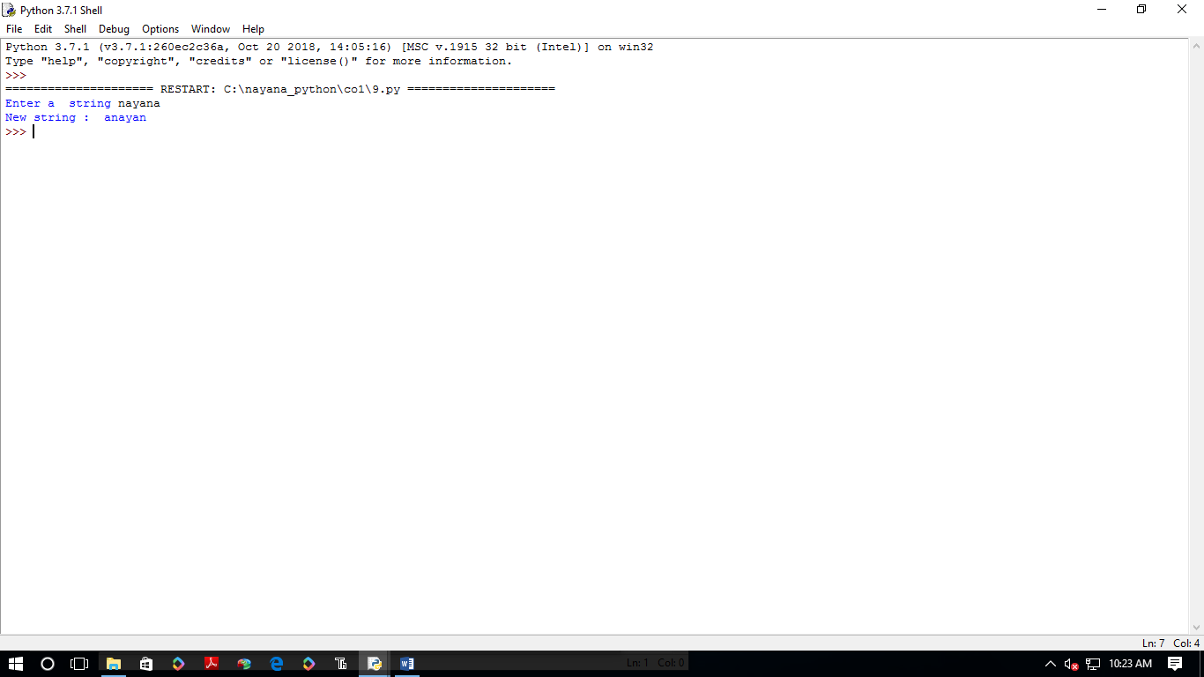

**10.Accept the radius from user and find area of circle.**

pi=3.14

r = float(input ("Input the radius of the circle : "))

result=3.14 *r**2

print ("The area of the circle with radius is: ", result)

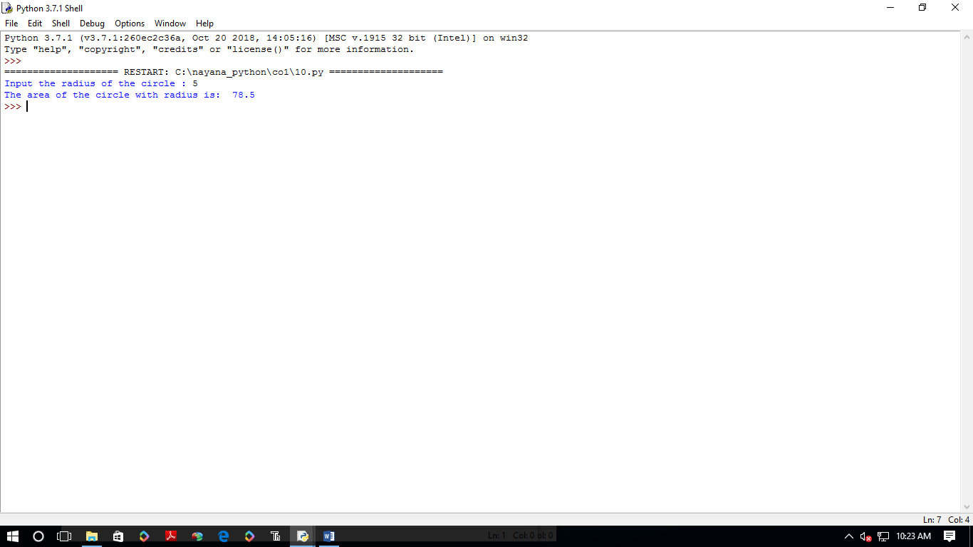

11. Find biggest of 3 numbers entered

x = int(input("Enter 1st number: "))

y = int(input("Enter 2nd number: "))

z = int(input("Enter 3rd number: "))

if (x > y) and (x > z):largest = x

elif (y > x) and (y > z): largest = y

else:largest = z

print("The largest number is",largest)

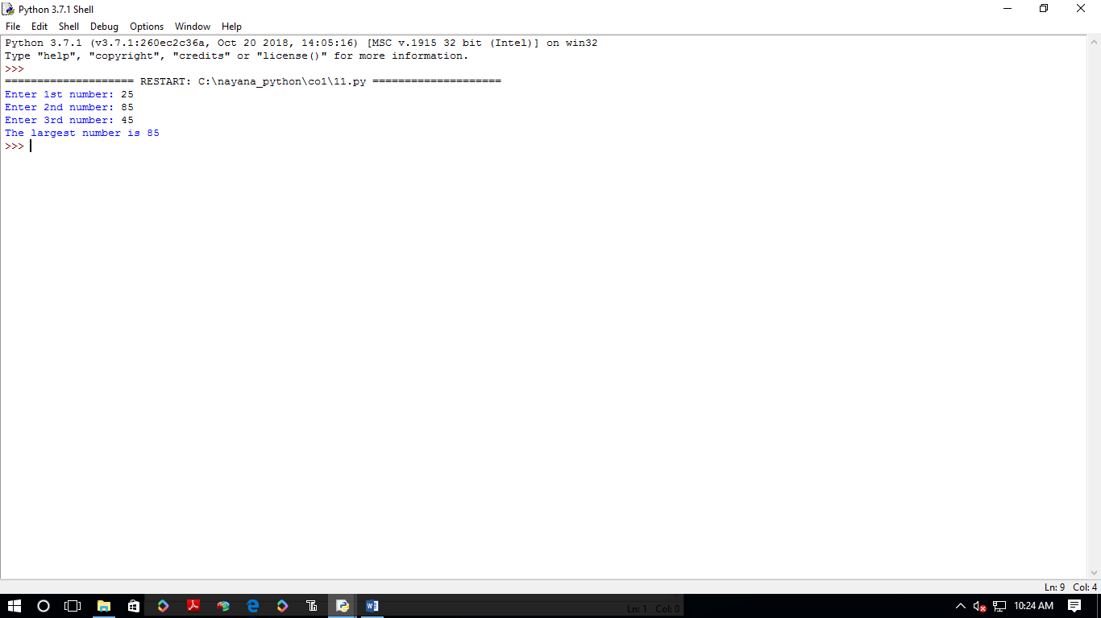

**12.Accept a file name from user and print extension of that**

file= input("Enter filename : ")

f=file.split(".")

print("Extension of the file is : " + f[-1])

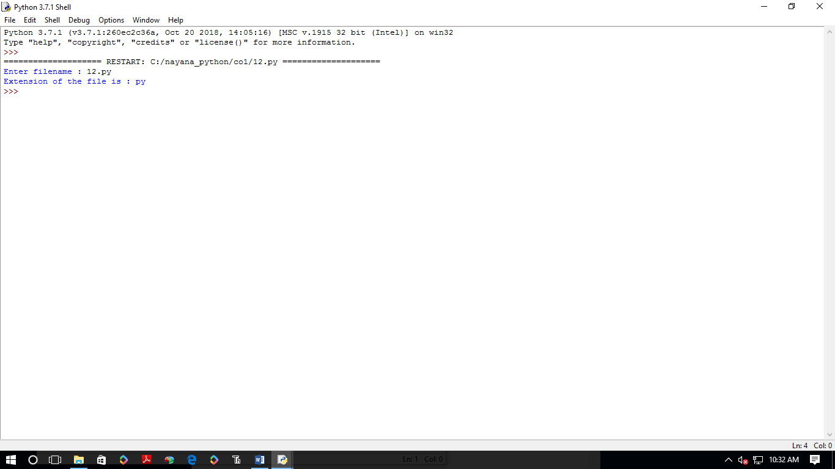

1. Create a list of colors from comma-separated color names entered by user.Display first and last colors.

a=[]

for i in range(3):

b=input("enter the color:")

a.append(b)

**OUTPUT:**

**enter the color:red**

**enter the color:blue**

**enter the color:black**

**['red', 'blue', 'black']**

**red**

**black**

**14.Accept an integer n and compute n+nn+nnn**

n=int(input("entera number:"))

x=int("%s"%n)

y=int("%s%s"%(n,n))

z=int("%s%s%s"%(n,n,n))

print("n+nn+nnn:",x+y+z)

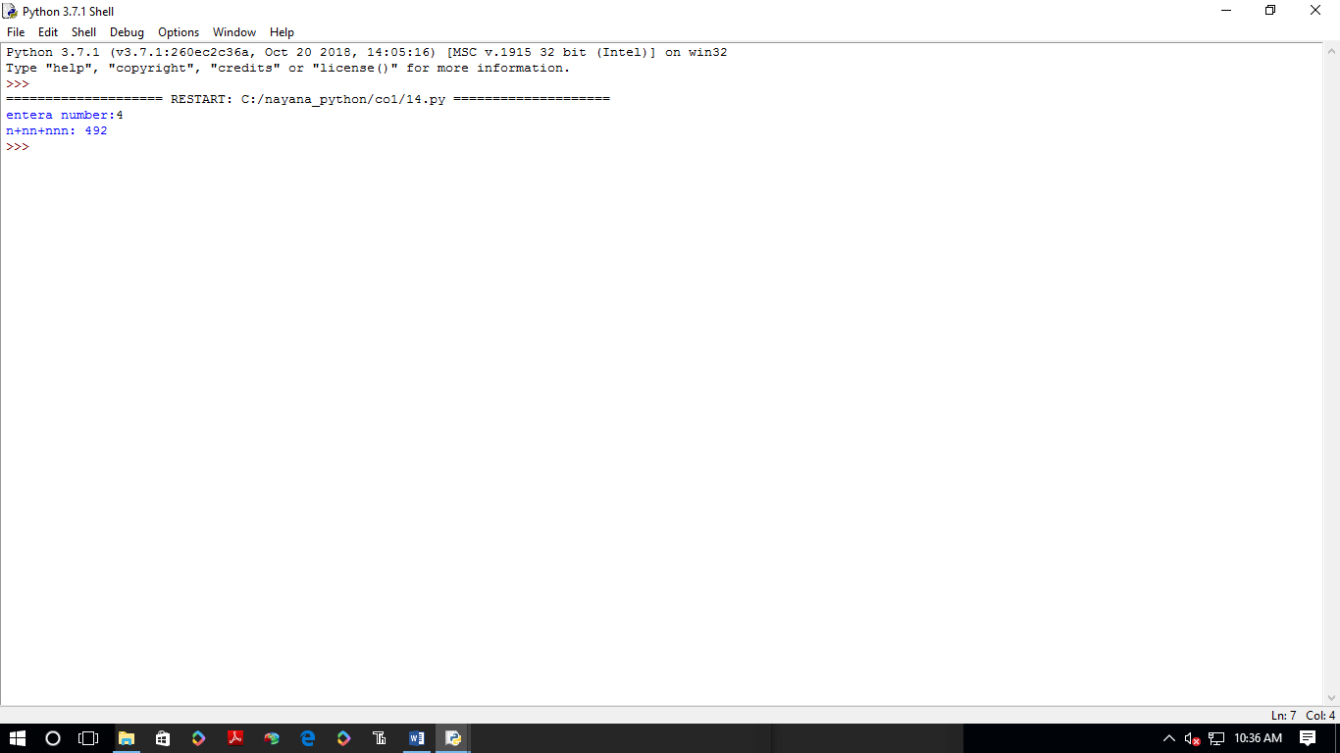

**15.Print out all colors from color-list1 not contained in color-list2.**

li1=set(["red","blue","green"])

li2=set(["green","violet","pink"])

print(li1.difference(li2))

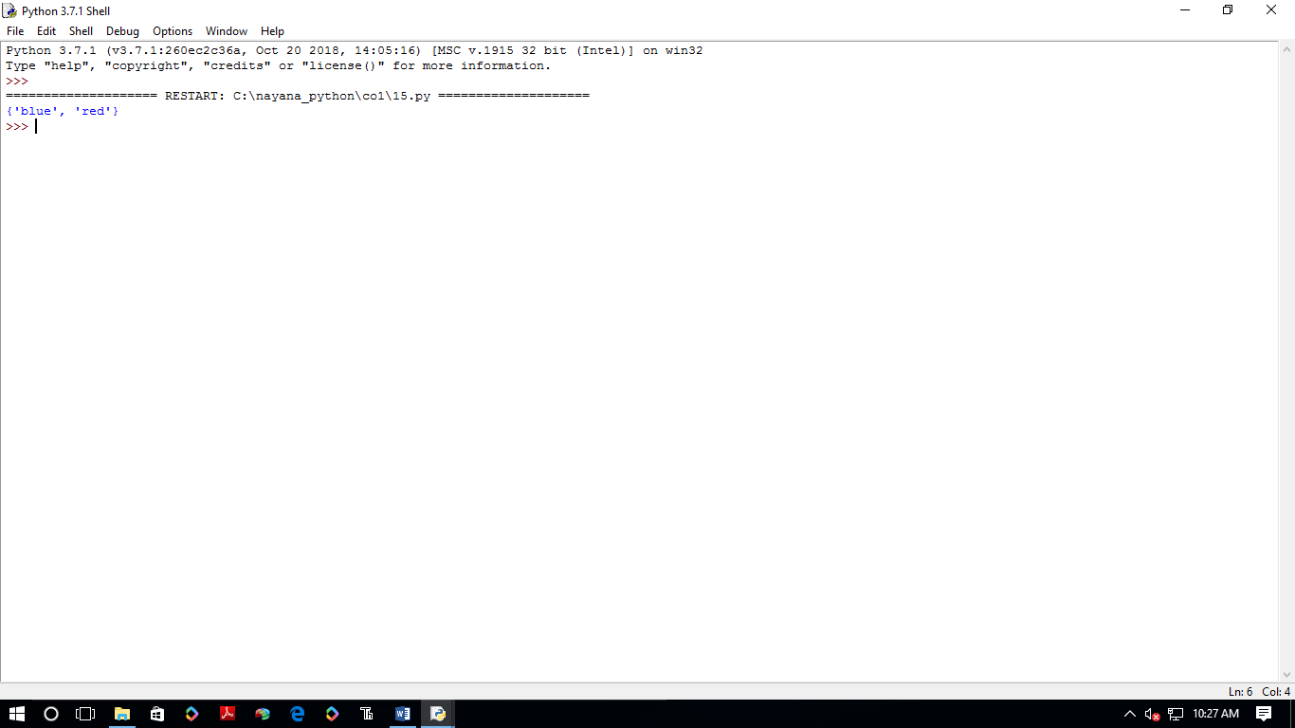

**16.Create a single string seperated with space from two strings by swapping the character at position 1.**

a="python"

b="lab"

p1=a[0]

p2=b[0]

c=b[0]+a[1:len(a)]+" "+a[0]+b[1:len(b)]

print(c)

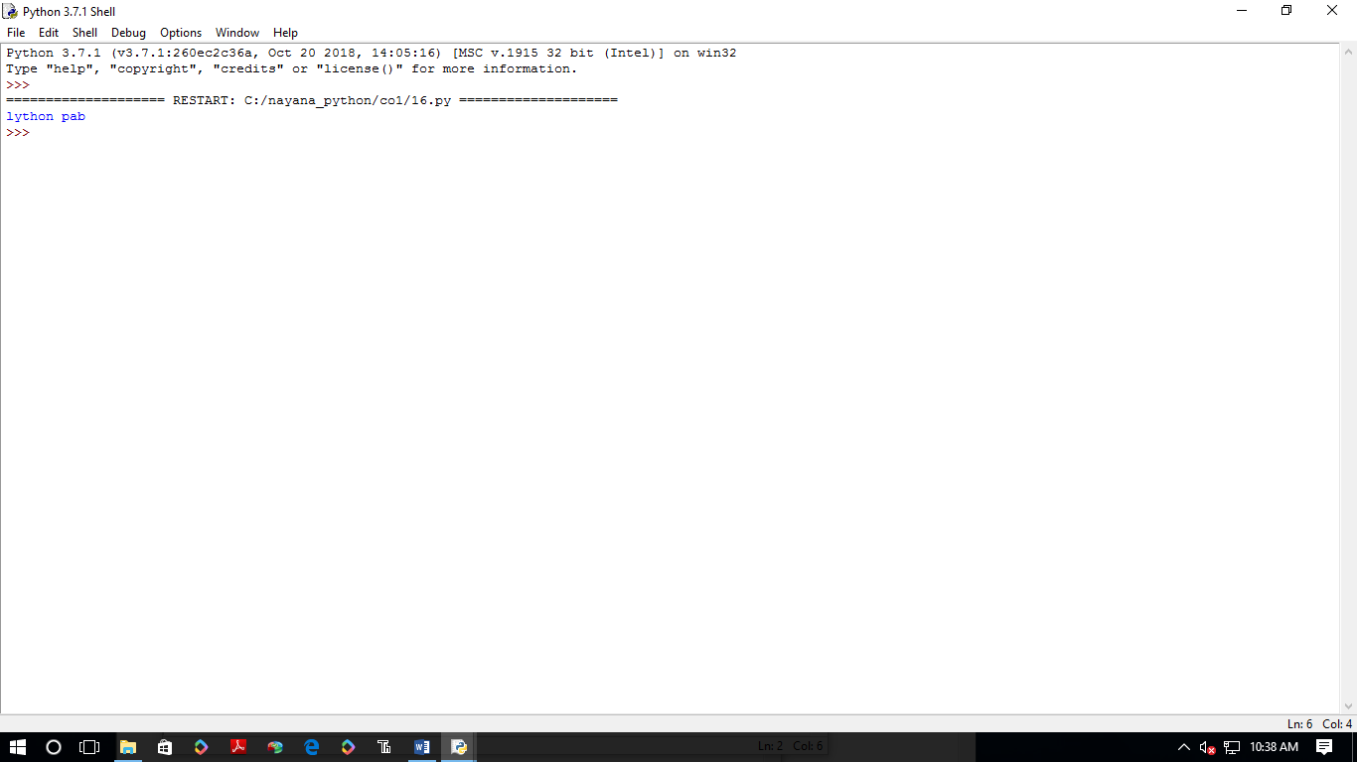

17.Sort dictionary in ascending and descending order.

import operator

d = {1: 2, 3: 4, 4: 3, 2: 1, 0: 0}

print('Original dictionary : ',d)

sorted_d = sorted(d.items(), key=operator.itemgetter(1))

print('Dictionary in ascending order by value ',sorted_d)

sorted_d = dict( sorted(d.items(), key=operator.itemgetter(1),reverse=True))

print('Dictionary in descending order by value : ',sorted_d)

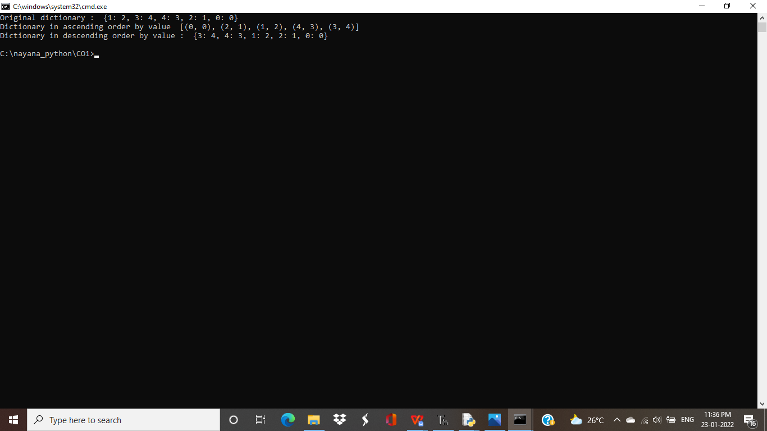

18.Merge two dictionaries

d1 ={ 'a': 100, 'b': 200}

d2 ={'x' : 300, 'y': 200}

print ("Dict ionary 1=:", d1)

print ("Dictionary 2-: ", d2)

d =d1. copy ()

d.update (d2)

print ("Merged Dictionary: ", d)

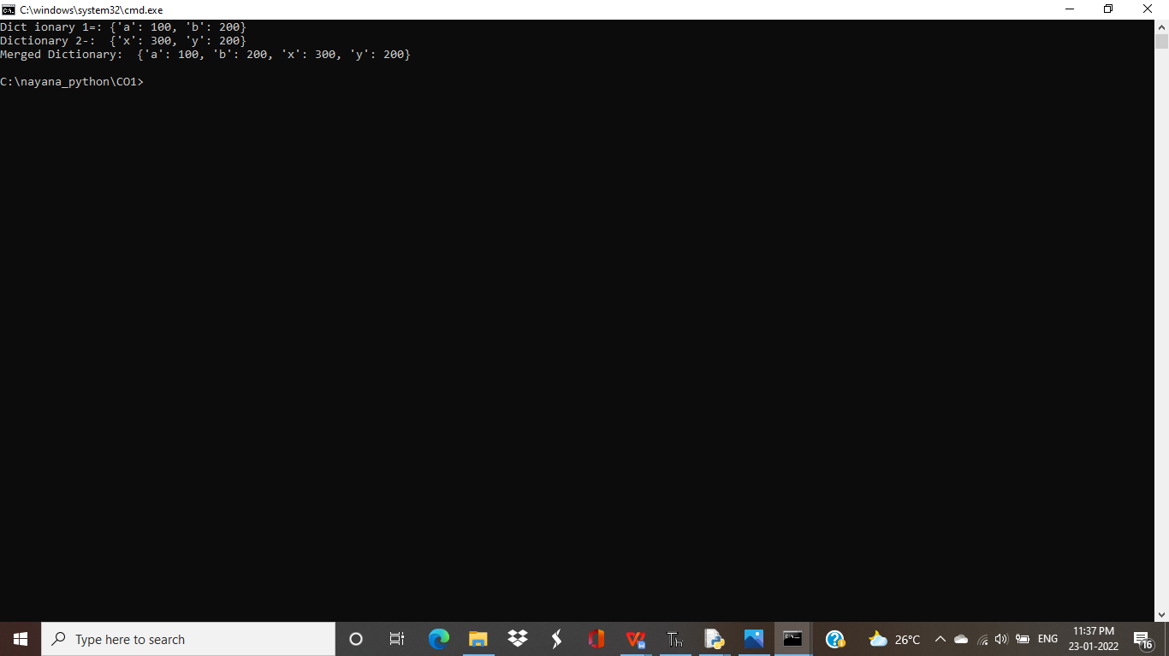

**19.Find gcd of 2 numbers.**

x=int(input("enter 1st no"))

y=int(input("enter 2nd no"))

i=1

while(i<=x and i<=y):

if(x%i==0 and y%i==0):

gcd=i

i=i+1

print("gcd",gcd)

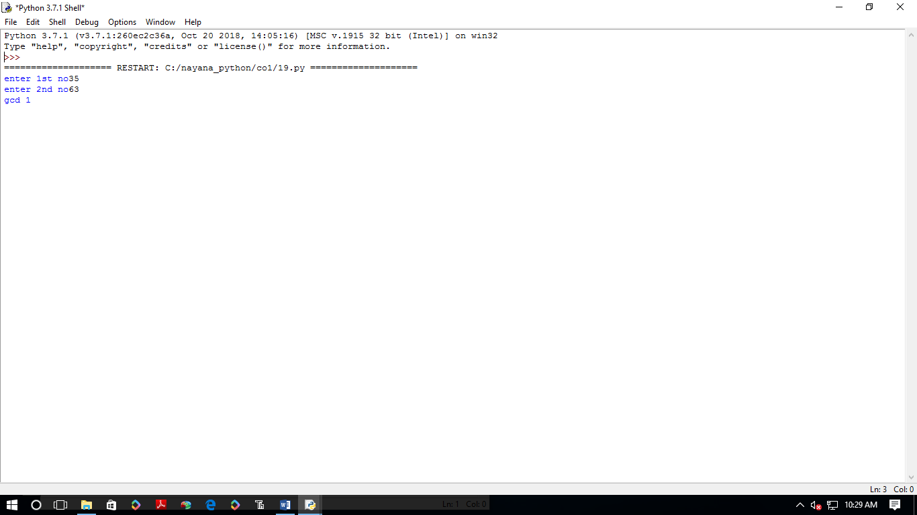

**20.From a list of integers, create a list removing even numbers**

num=[3,4,7,8,24,88]

print("original list:",num)

num=[x for x in num if x%2!=0]

print("list after removing even numbers:",num)

